Work Flow:

|  |  |  |
| --- | --- | --- |
| Wireframing  It is a rough layout usually made by pen and paper or online tools like balsamiq.cloud  Template at  <https://sneakpeekit.com/> | Mock-up  Made using Adobe InDesign, Photoshop or Illustrator  A future version of app or website | Prototype  Going a step further and hard coding it to implement |

Colour Theory

RED: love, energy and intensity.  
YELLOW: joy, happiness and intellect. This attracts a lot of attention.  
GREEN: Freshness, safety and growth.  
BLUE: Traditional, stability and serenity.  
PURPLE: Royalty

Colour Palettes Combination:

1. Complementary Colours and Analogous Colours on Colour wheel.
2. Complementary Colours are very clashy so it is better to rather have the analogous colors of complementary colours to make less clashy.
3. Triadic colours on color wheel.
4. Monochromatic colours on colour wheel – Contemporary and modern.

[www.ColorHunt.com](http://www.ColorHunt.com)

[www.coolors.co](http://www.coolors.co)

[www.flatuicolors.com](http://www.flatuicolors.com)

[www.materialpalette.com](http://www.materialpalette.com)

Colorzilla – extension

Typography:

Types of typefaces:

1. Serif – for something very serious (Differentiate on basis of difference between thickness of most thick and least thick and go top to bottom:)
   1. Old style in 1400s – Adobe Jenson
   2. Transitional – Baskerville
   3. Modern – Didot
   4. Slab-serif – American Typewriter. (Used for newspaper printing – to hide poor quality paper)
2. Sans-serif – Modern (same as serif differentiate)
   1. Grotesque – oldest (News Gothic)
   2. Neo-Grotesque – Helvetica
   3. Humanist – Gill Sans
   4. Geometric – Futura (The o’s are totally circular)

Typography determines readability. Readable fonts have more open shapes and ample intercharacter spacing, unambiguous forms and varying proportions.

Serifs and sans-serifs bind good.

Too many fonts are not good. 2 is ideal, 3 is avoided and 4 is kill.

Eras of typographic families should be same. Go for similar mood.

Never use these six fonts:

1. Kristen
2. Comic Sans
3. Papyrus
4. Viner
5. Curlz
6. Euyboy

WhatFont extension.

[www.fontsquirrel.com](http://www.fontsquirrel.com)

User Interface:

Brain first goes from big to smaller elements.

Alignment:

The number of alignment lines should be least.

The edge alignment is better for User Interface.

There is also centre alignment.

Lighting:

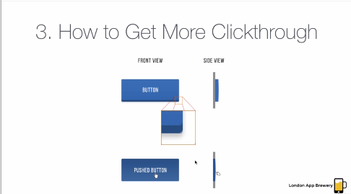

Light should always come from above. Elements should be more lifelike.

Start with a design that is completely basic and then introduce color.

Making Text visible on Images:

Use a high opacity background behind text.

Or have a color overlay to make it more visible.

Or you can blur.

Or you can have a gradient transparent.

How to direct User attention:

Use spacing, font weights, right fonts, right shade of colours.